Here are some choices the director and actors considered:

Anagrams of 'Senator Hillary Rodham Clinton'

Accepted anagrams:
"Senator Hillary Rodham Clinton"->"The oration? Hardly a Mrs. Lincoln!" (by Mike Mesterton-Gibbons by hand) (2004)
"Senator Hillary Rodham Clinton"->"Slim North Carolina lady? Not her." (by Mick Tully using Anagram Genius) (2005)
"Senator Hillary Rodham Clinton"->"Handle my arrant ol' clitoris, hon'." (by Mick Tully using Anagram Genius) (2005)

Pending anagrams:
"Senator Hillary Rodham Clinton"->"So roll in M. Thatcher, an Iron Lady!" (by Mick Tully using Anagram Genius) (2007) (pending approval)
"Senator Hillary Rodham Clinton"->"Intern to calm his hard on - orally." (by Mick Tully using Anagram Genius) (2006) (pending approval)
5 results

http://www.anagramgenius.com/

Donald Rumsfeld anagrams
Rearranging the letters of 'Donald Rumsfeld' (George W. Bush's Secretary of Defense) gives:
 | 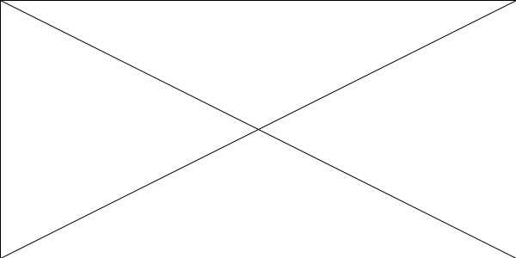
  Fond dull dreams. | (by Terry Ballard) (2004)
  Slumland fodder. | (by Benjamin Yardley by hand) (2003)
  Land of muddlers. | (by Rick Rothstein using Anagram Genius) (2003)
Me? Droll? Adds fun. | (by Rick Rothstein using Anagram Genius) (2003)
Armed dolls' fund? | (by Mike Mesterton-Gibbons by hand) (2003)
Smaller DoD fund? | (by Mike Mesterton-Gibbons by hand) (2003)
Small DoD refund? | (by Mike Mesterton-Gibbons by hand) (2003)
Led old arms fund? | (by Mike Mesterton-Gibbons by hand) (2003)
Dull and deforms. | (by Mike Mesterton-Gibbons by hand) (2003)
Muddler of lands. | (by Mike Mesterton-Gibbons by hand) (2003)

Former President Bill Clinton anagrams
Rearranging the letters of 'Former President Bill Clinton' (US President) gives:
Blind flirt or complete sinner. | (by Bruce Breedlove using Anagram Genius) (2000)

"Senator Hillary Rodham Clinton"->"Intern to calm his hard on - orally." (by Mick Tully using Anagram Genius) (2006) (pending approval)

President Obama anagrams
Rearranging the letters of 'President Obama' (Winner of US Presidential election in 2008?) gives:
Some adept brain! | (by Judson T. Pewther using Anagram Genius) (2006) (pending approval)
I am sober 'n' adept. | (by Judson T. Pewther using Anagram Genius) (2006) (pending approval)
I'm a sober pedant. | (by Judson T. Pewther using Anagram Genius) (2006) (pending approval)

Deem as top brain. | (by Judson T. Pewther using Anagram Genius) (2006) (pending approval)

Other related anagrams without their own page:
"President Barack Hussein Obama" -> "BBC here. USA's top-rank idea-man is ~" (by Judson T. Pewther using Anagram Genius) (2006) (pending approval)
"President Barack Hussein Obama" -> "Unkind Arabs? America's best hope." (by Judson T. Pewther using Anagram Genius) (2006) (pending approval)
"Democratic Senator Barack Obama" -> "Abracadabra! Tame cockiest moron!" (by WomanSansIcon using Anagram Genius) (2006) (pending approval)
"U.S. Senator Barack Hussein Obama" -> "A heroic urban man as USA's best, OK?" (by Judson T. Pewther using Anagram Genius) (2006) (pending approval)
"Senator Barack Obama" -> "Trace Arab knob Osama!" (by Mick Tully using Anagram Genius) (2007) (pending approval)
"Senator Barack Obama" -> "A kebab-cartons aroma!" (by Mick Tully using Anagram Genius) (2007) (pending approval)
See also:

Senator Barack Hussein Obama anagrams
Rearranging the letters of 'Senator Barack Hussein Obama' gives:
Ah, mean Arab's best crook in USA! | (by Aronas Pinchas) (2006) (pending approval)
I shone, babe, a USA rock star man! | (by Mike Mesterton-Gibbons by hand) (2006) (pending approval)

Other related anagrams without their own page:
"Democratic Senator Barack Obama" -> "Abracadabra! Tame cockiest moron!" (by WomanSansIcon using Anagram Genius) (2006) (pending approval)
"President Barack Hussein Obama" -> "BBC here. USA's top-rank idea-man is ~" (by Judson T. Pewther using Anagram Genius) (2006) (pending approval)
"President Barack Hussein Obama" -> "Unkind Arabs? America's best hope." (by Judson T. Pewther using Anagram Genius) (2006) (pending approval)
"U.S. Senator Barack Hussein Obama" -> "A heroic urban man as USA's best, OK?" (by Judson T. Pewther using Anagram Genius) (2006) (pending approval)
"Senator Barack Obama" -> "Trace Arab knob Osama!" (by Mick Tully using Anagram Genius) (2007) (pending approval)
"Senator Barack Obama" -> "A kebab-cartons aroma!" (by Mick Tully using Anagram Genius) (2007) (pending approval)

